Search

*Enter Search Text…*

login

Create Account

**Web Site Title**

**Footer Text**

**Charity Website - Wireframe**

What we do

Useful information

Donate

Get Involved

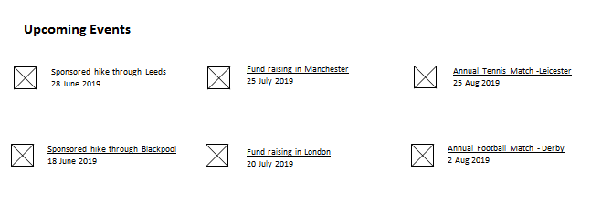

**Promoted Charities**

*Search events*

Arrange Events by Date

Search

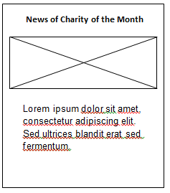

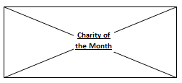

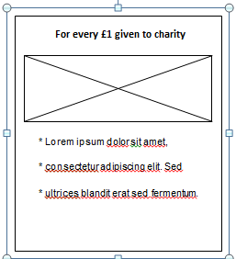

**Other Useful information**



**Reason behind updating wireframe as above:**

The small image thumbnails have been removed because on the displayed page they were coming as too small (to match up with size of adjoin text) and therefore could not serve the intended purpose of providing more information related with upcoming events.

When tested the website with small thumbnails it reduced accessibility, desirability and usefulness of the front page. Therefore the thumbnails removed to improve accessibility and usability of the final version of the project.